
Lake Tekapo School
ENROLMENT PACK

Information & Forms
2020
Dear Parents/Legal Guardians /Caregivers,

"You don't need to teach a child curiosity. Curiosity is innate, you just need to be careful not to quash it. This is the challenge for the teacher - to foster and guide that curiosity."
Sir Paul Callaghan (1947–2012)

Welcome to Lake Tekapo School and we look forward to working with you and your child. Starting school is an exciting and important step in your child’s life and we are looking forward to supporting this transition with you.

When working with you and your child we are very conscious that as parents or caregivers, you have a wealth of information to share with us. We know and respect this. We pride ourselves on having an open door policy with communication between home and school genuinely valued as the most important part of your child’s learning. You are invited and encouraged to discuss any issues, queries or concerns informally or at an arranged time with us.

Yours sincerely,

Simon Waymouth
Principal.

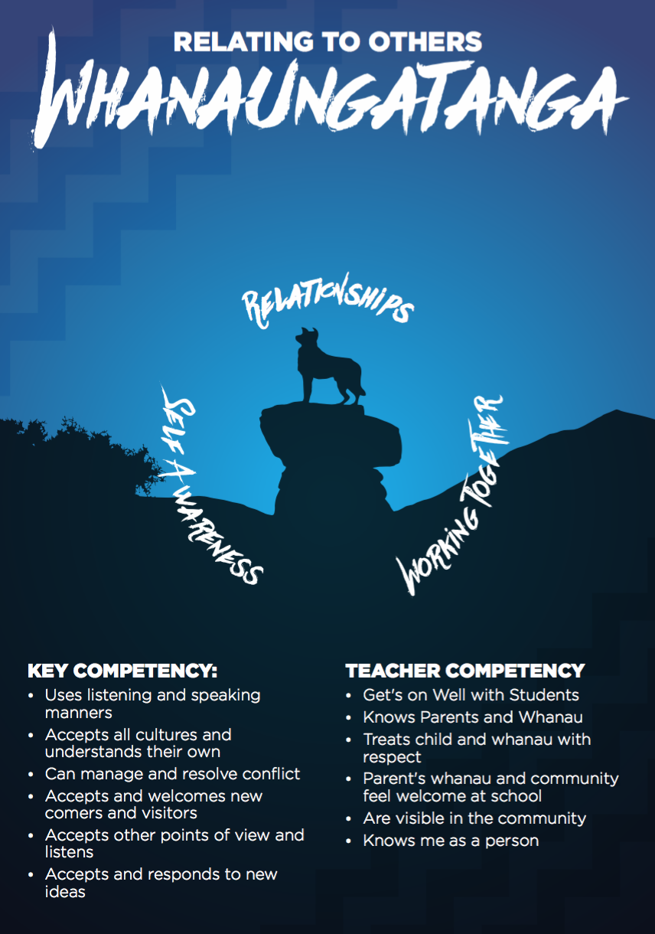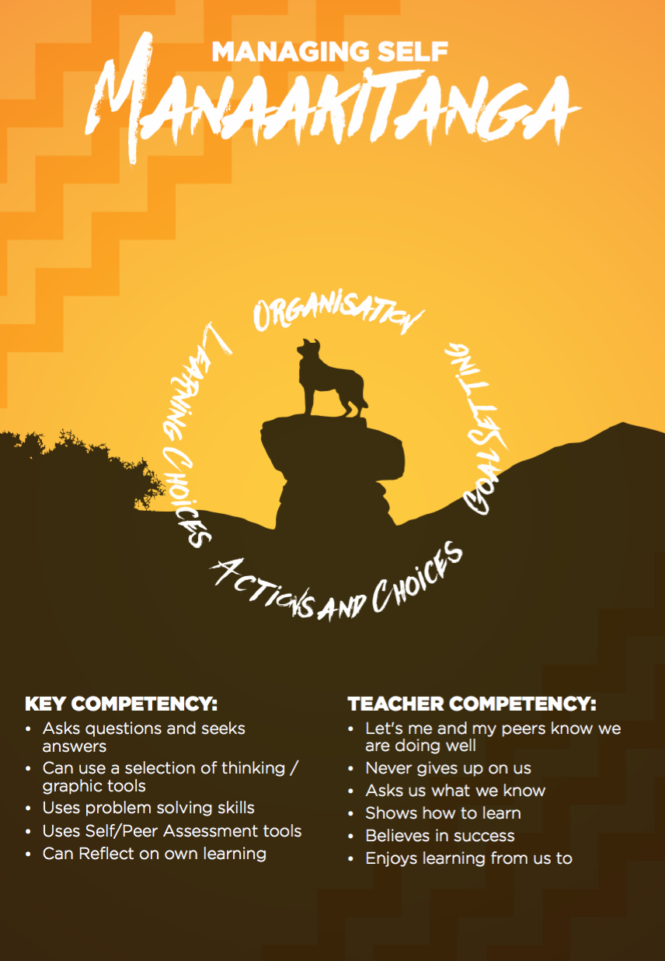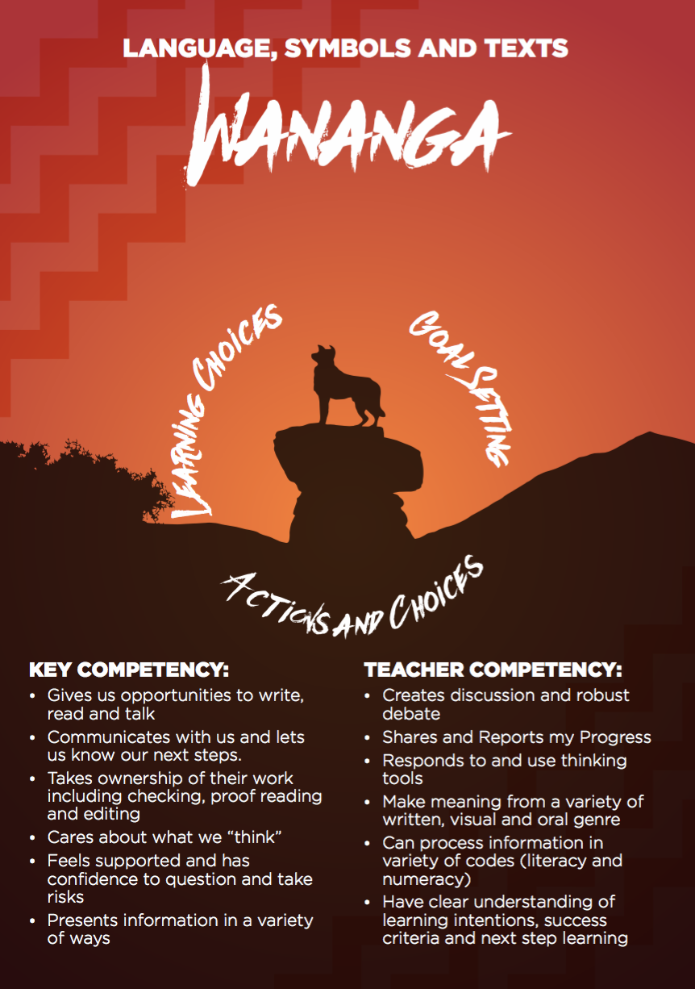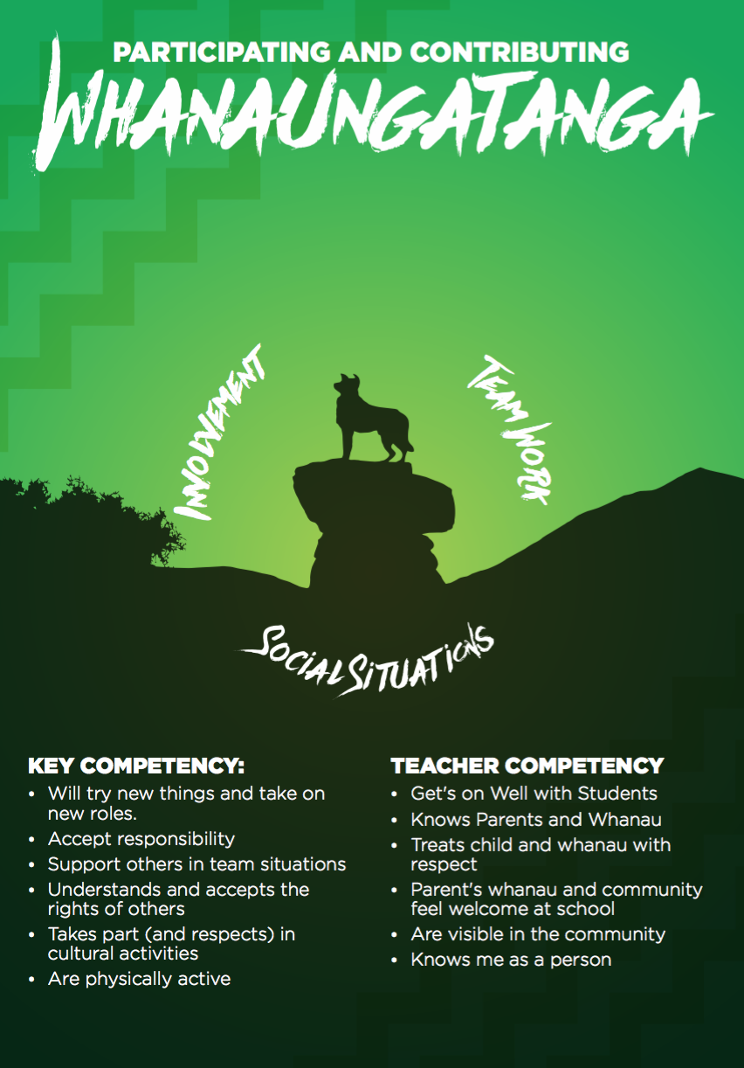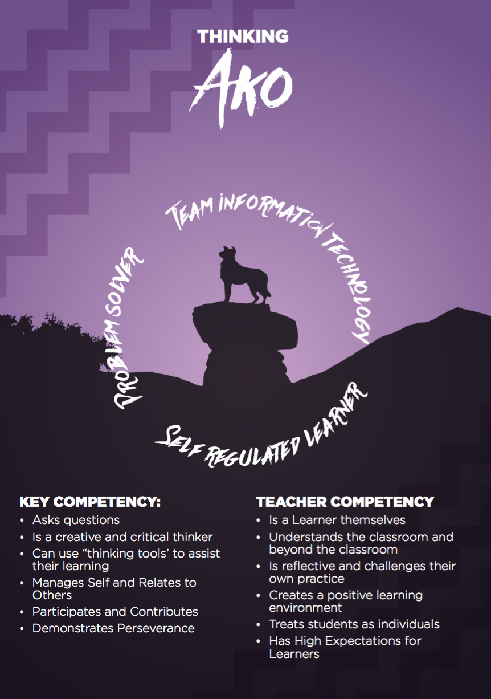

School looks a little different now………….

Lake Tekapo School’s main focus is on the 5 Key Competencies outlined in the New Zealand Curriculum. These link directly to Te Whariki (Early Childhood Curriculum) and help us form the basis for developing learners for life. These are Thinking, Managing Self. Participating and Contributing, Relating to Others and Language, Symbols and Texts. When teachers are forced to teach to the test, they themselves become less innovative with their teaching methods, with less room for learning games, play and curiosity. At Lake Tekapo School our focus is on more creative teaching methods to explore and build upon your child’s interests and passions.

Play is Real Learning to …….
Play is what young children do, it is what they know and it is what they are good at. Play is not some sort of soft approach before “real learning begins”. It is play that has been described across time as central to thinking, language and social development. Sarah Whiting (Core Education)

We reinforce this idea through rewarding learning behaviors…..

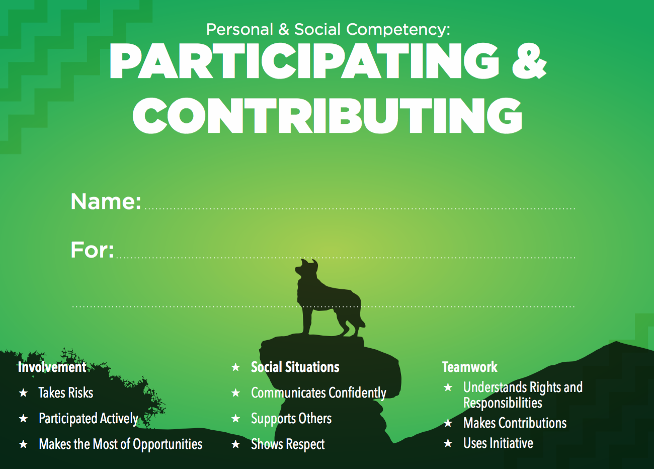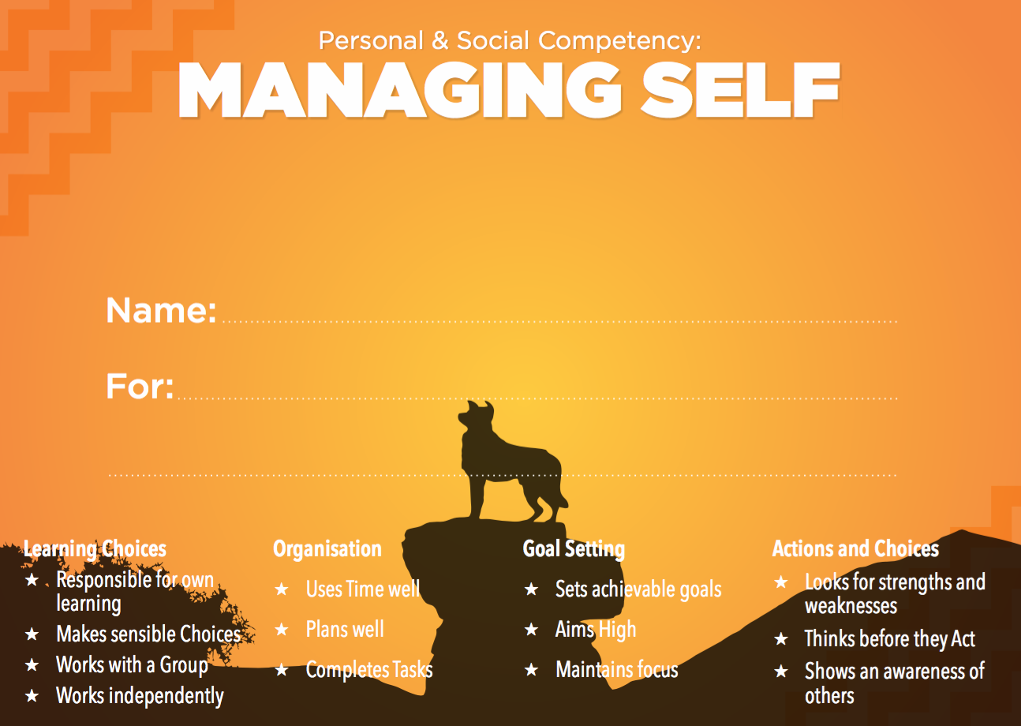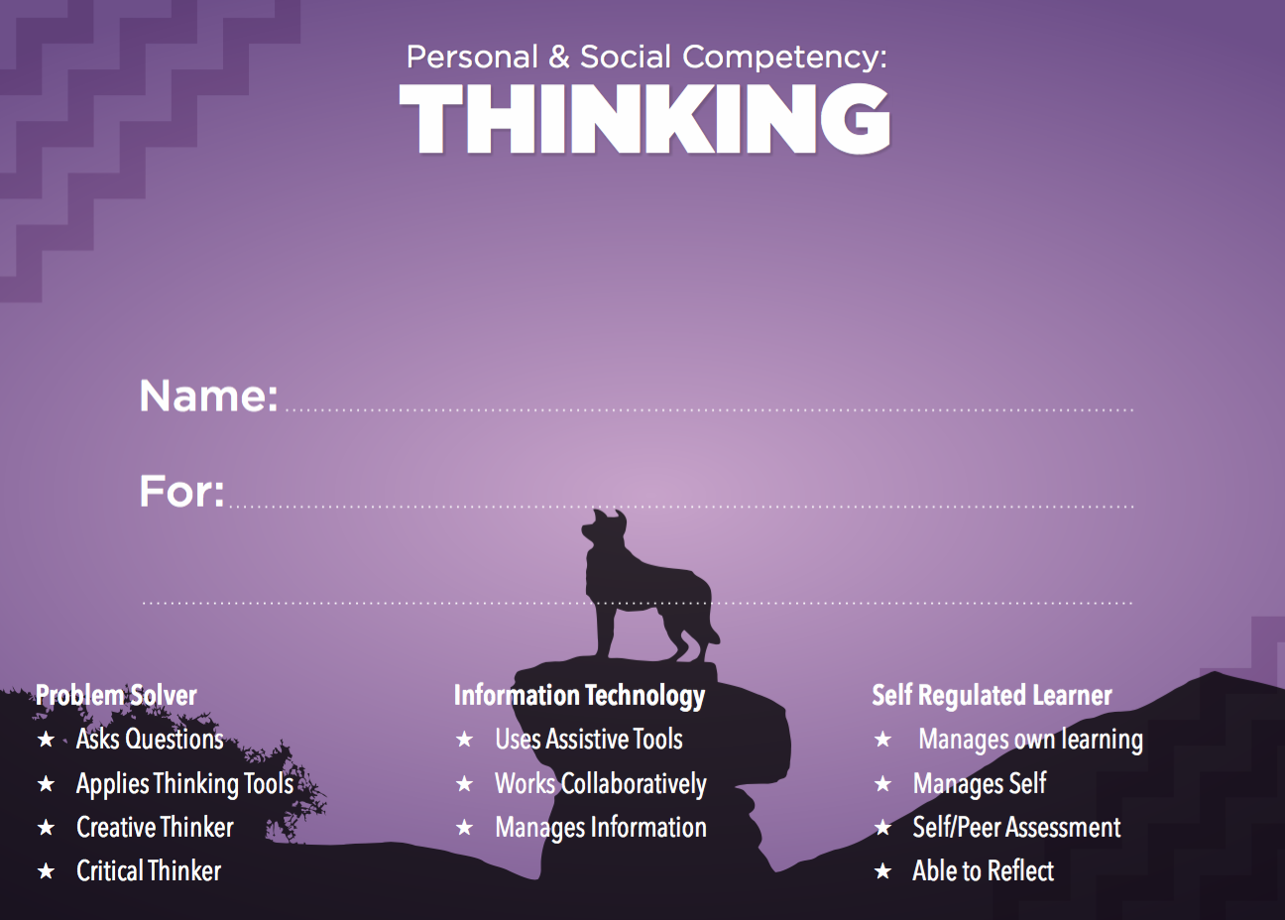

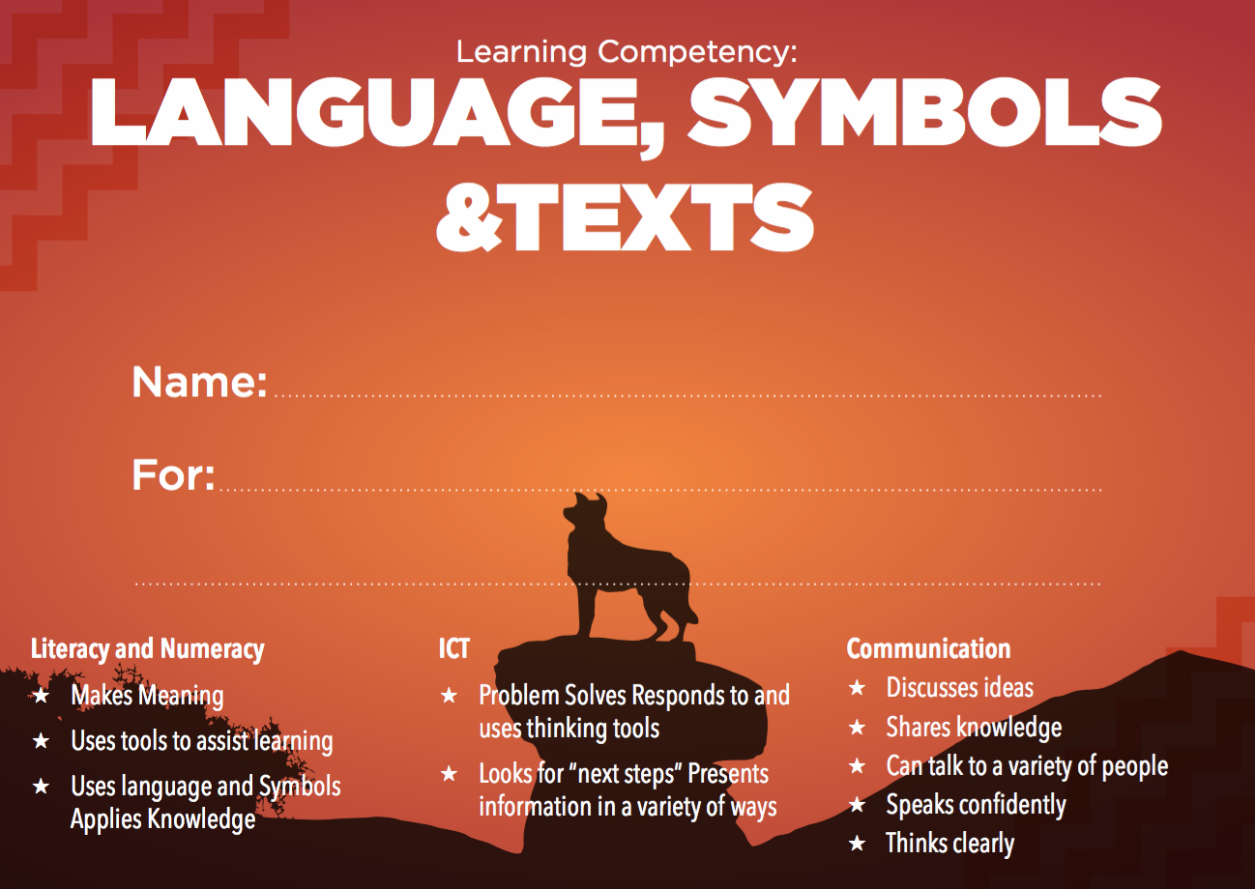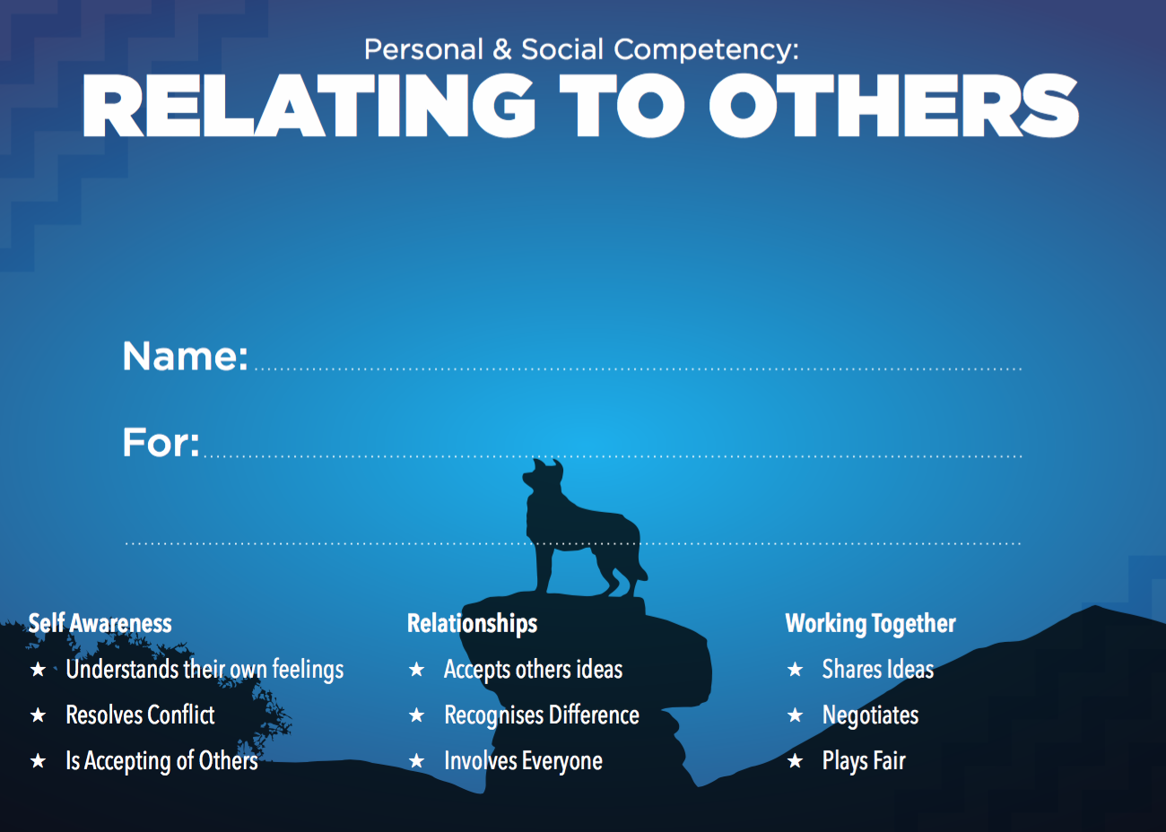

Reading
Our aim is to enthuse children about reading, and to develop and share a love of books.
Reading happens across the day in many ways. We read as a whole class when we share stories together, read poems and each other’s work. We explore the language and pictures in big books and work in small groups with the teacher. Each class has a library slot with a library that is always being reviewed for new books by our friendly librarian.

Ways to help….
- Notice signs and labels when you are out and about
- Talk about your day together
- Visit the Library and share your reading
- Point out your child’s name when you see it written
- Point to each word
- Know some of the basic words
- Relate pictures to print
- Read

Sound Work….
Knowing the names of letters is not as important as the ability to hear and repeat sounds.
- Listen for the differences and similarities between sounds … play with rhymes.
- Have fun with Nursery Rhymes, story telling and retelling fairy tales.
- Listen for outside sounds and make your child aware (traffic, wind, trees etc) … otherwise they may just say “nothing”

Home Learning:
Children will bring home a book each night to share (the book may change each night or be the same for several days). This is a fun time for your child to share something they have been doing at school and celebrate their success. This book will be easy reading for your child however at times they will need prompting or even for you to read the book to them if they are tired or unfocussed. In time your child will have more homework added to help with their learning.
Library books and poetry books will also come home once a week to share. You will be informed on your child’s homework sheet when these need to be returned to school. Please ensure all books are returned to school. Encourage your child to place the book in his or her own folder and to return the folder to their desk each morning.
Mathematics
Our aim is to be excited about Maths and experience success so they can solve everyday, real life problems, creatively, critically and logically.



Maths is not just about numbers ….. It is about seeing patterns, making connections and problem solving. Mathematics at Lake Tekapo School focuses on all the strands of Math.
- Numeracy
- Algebra
- Geometry and Measurement
- Statistics.
Ways to help….
- Look at numbers on the mailbox and read them out
- Cook together
- Count cars
- Time your child running around the house
- Play snakes and ladders
- Sort Lego into sizes and colours
- Read and write the numerals 1 to 20
- Say the numbers 1 to 20 forwards
- Say the numbers 1 to 20 backwards
- Count the number of objects in a set up to 10


Writing
Our aim is for children to develop a love for the written voice.

Children are excited about being able to share their personal stories. Encourage your child to be a writer by mark marking, telling stories, drawing pictures and performing.

Ways to help….
- Help your child plan their ideas by drawing with them
- Find words in your daily lives and talk about them
- Record the sounds your child makes
- Have fun with words – silly word, use of alliteration, sound word etc

Daily Routine:
Our class timetable is as follows (although is subject to change):

Reporting:

Seesaw is an online tool which will act as a journal of your child’s learning while they are here at Tekapo. Reporting in plain language helps parents and whanau be well infomred and means that the reporting is “at the moment” reporting rather than waiting for formal times. Plain language written reporting, alongside the visual element of seesaw presents your child’s learning journey that is easily understood. The Reporting schedule for 2020 is….

- Term 1 – Parent teacher interview – Did not happen due to COVID 19
- Term 2 – Parent Interview and Seesaw Written Report – Term 2
- Term 3 – Parent teacher interview and Seesaw
- Term 4 – End of year written report

We welcome informal discussions about your child’s progress at any stage.

Pre-school Visit:
As part of the enrolment process, times will be arranged for you and your child to have school visits. The first 2 visits will be for ½ a day each to ensure your child gets a sample of a typical school day and a smooth transition to school. After this, your child will move to full day visits.

Students who turn 5 years during January – April will be classified as Year 1 students. Students who enter after April will be classified as either Year 0/1 depending on social or academic ability. Students who enter school from May onwards will automatically be classified as Year 0 for the remainder of the year. The following year, they will enter Year 1.

On arrival it would be helpful if your child is able to:
- Recognise/write his/her own name.
- Manage scissors and crayons
- Know their manners – please, thank you, sorry
- Hold a pencil
- Can manage their own clothes and shoes
- Has had some experience with books and alphabet knowledge
- Follows instructions
- Able to handle food and can pack and unpack their own bag
- Knows it is o.k. to ask
- Can sit down for a short time and listen
- Can manage the toilet unassisted.

This is just a guide for an easier transition for school. We would want to reassure you that there are no requirements for starting school. It is our job to be ready for your child even if they are not yet ready for school. We want your child to be happy, feel respected and continue to develop a love for learning.

School Hours:

Our classrooms are open for you and your child from 8.30am. The school bell is rung at 8.55am to start the day. All children will finish school at 3pm. Please discuss fully with your child who will be meeting him or her at the end of the day and please let the teacher know if arrangements change.
Should you find your child becoming tired in the first months of school you are welcome to make arrangements with the teacher to collect them earlier until they have adjusted to school routines.

What Your Child Needs:

Could you please ensure your child has the following items ready for their first day.
- Personal articles /clothing, which must be clearly named

- School uniforms are available for purchase through online ordering (see attachment)

- Backpacks – if you are purchasing, please ensure the backpack is big enough to fit items comfortably i.e. lunchbox, reading folders etc., but not too big for the child’s size.



Terms 1 and 4 – a brimmed hat is required to be worn outside at all times.
Terms 2 and 3 – socks and/or slippers are to be worn on the carpet in the classroom.

School Lunches:
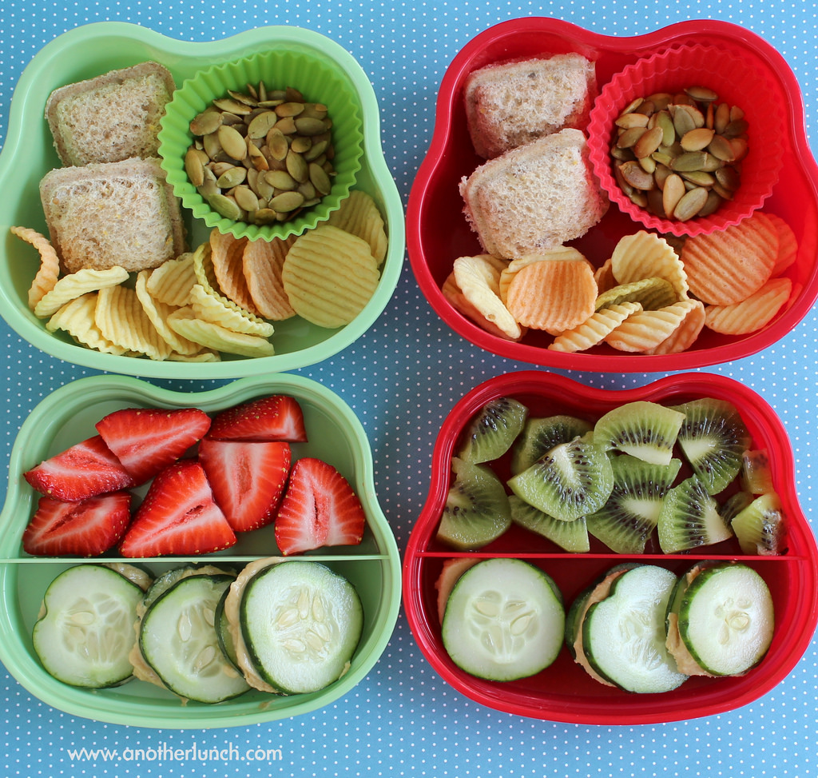

We hope you will support us by promoting a healthy attitude to food, providing ‘healthy’ morning teas and lunches. Drinking water is promoted regularly and we ask that your child has a drink bottle for the classroom.

In term 2 and 3 children will be able to bring lunches to be heated in our “toasty kai warmer”.

If you have any questions, please ask or if you want to make contact at any time, you are most welcome to email us:

simon@tekapo.school.nz
melissa@tekapo.school.nz

We look forward to working with you and your child/ren.

Simon Waymouth
Principal

